
PES University, Bangalore UE18MA251
(Established under Karnataka Act No. 16 of 2013)

END SEMESTER ASSESSMENT (ESA) B.TECH. IV SEMESTER-
UE18MA251- Linear Algebra and its Applications

Time: 3 hrs Answer All Questions Max Marks: 100

1 | a | Apply elimination and back substitution to solve :  2x – 3y = 3  4x – 5y + z = 7  2x – y – 3z = 5. | 6
1 | b | Compute L and U for the symmetric matrix A=  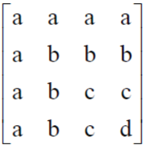 | 7
1 | c | Using Gauss Jordan method, find the inverse of A=  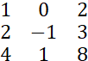 | 7
2 | a | What are the special solution to Rx = 0 and RTy = 0 for these R?  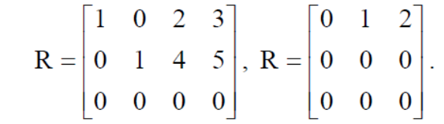 | 6
2 | b | Find the dimension and Basis for the Four fundamental subspaces for  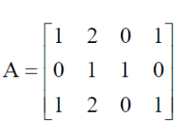 | 7
2 | c | Construct a matrix whose nullspace consists of all multiplies of (4, 3, 2, 1). | 7
3 | a | If W1, W2, W3 are independent vectors, show that the sums V1 = W2 + W3, V2 = W1 + W3  and V3 = W1 + W2 are independent. | 6
3 | b | Find the orthogonal complement of the plane spanned by the vectors (1, 1, 2) and (1, 2, 3) by taking these to be the rows of A and solving AX = 0. | 7
3 | c | Find the projection of the vector ‘b’ onto the line in the direction of ‘a’ where b = (1, 2, 3)  and a = (1, 1, 1). Also find the projection matrix. | 7
4 | a | Find the 3 by 3 matrix A and its pivots, rank, eigen values and determinant given  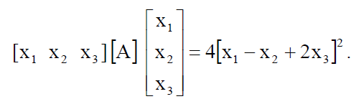 | 8
4 | b | Prove that  is positive semidefinite by all 5 tests. 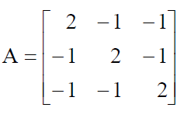 | 6
4 | c | Apply the Gram-Schmidt process to  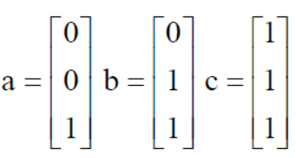  and write the result in the form A = QR | 6
5 | a | Find the largest eigen value and the corresponding eigen vector of A of power method given  That A=  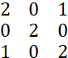  Taking [1 0 0]^{T} as the initial eigen vector | 12
5 | b | Diagonalize A and compute SΛ^{K} S⁻¹ to prove this formula for A^{K} :  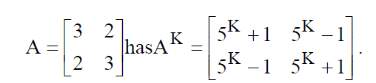 | 8

